Writing 5

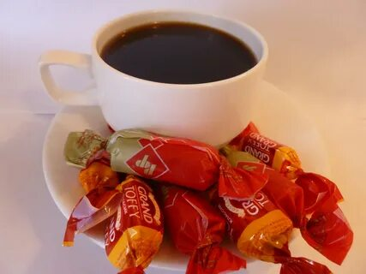**Ivan, Saint-Petersburg, Russia** *10 mins ago*

Breakfast is not important for me. I have a cup of coffee or tea and chocolate candies usually.

If I really have breakfast, then I have bread with butter and fragrant sausage. Also, I like delicious oatmeal porridge. But I never have fresh pickled cucumbers at breakfast.

I usually have a breakfast at home, but at the Friday I have it in cafe. I like to eat!